Edit on Pro and replicate to Pub

Should be automatically published if done correct.

Edit using

J:\apps\Python\LayerUpdates\zoning\processing\Zoning_Editing.mxd

How to add a Feature template:

Select the Organize Templates button (under Create Features.

Select the Unit Zoning layer under Layers.

Select the Template. Select View > All Fields.

Apply the Unit number to the Unit field.

Hit Apply.

Can do a bunch at a time

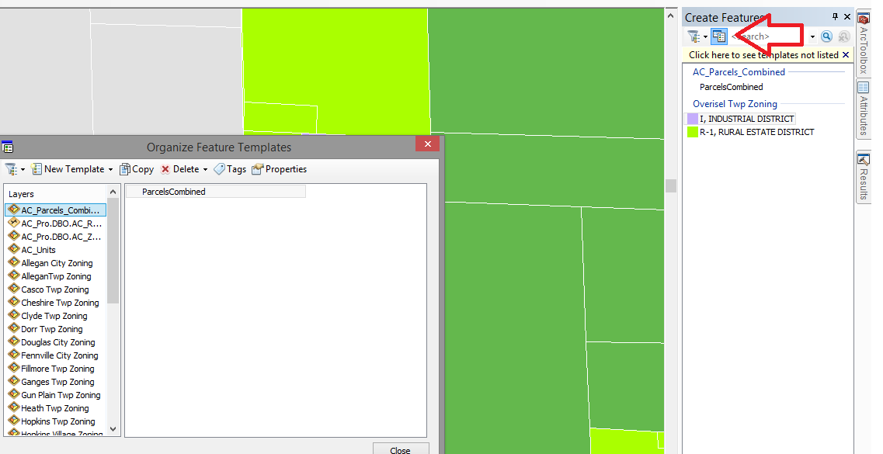

Style Manager

Customize > Style Manager > j:\symbology > ACstyle.style

Go into Create Features > Organize Feature Templates and set the Unit Number!!!!